English
Block-1
Aanya And The Dragon
I. Keywords :-
- Aanya
- Dragon
- Free
- Lonely
- Afraid
- Brave
- Crutches
- Scared
- Ride
- Flew
II. Meaning :-
- Scared – Afraid
- Lonely – Alone
- Free – Able to get out
- Crutches – Stick that help a person to walk
- Brave – Not scared
- Pond – A body of water smaller than a lake
II. Answer the following questions :-
- Who was Aanya ?
Ans:-Aanya was the princess.
- Where was the dragon ?
Ans:-Dragon was chained in the King’s palace
- How was the dragon ?
Ans:-Dragon was lonely and sad.
- Write the charters in the story.
Ans:- a. Aanya b. Dragon c. King.
V.Add s or es write the pleural :-
- Table – Tables
- Class – Classes

- Fox – Foxes
- Kite - Kites
- Peach – Peaches
- Photo – Photos
- Brush – Brushes
- Tomato – Tomatoes
- Dress – Dresses
- Sandwich – Sandwiches
V. Draw the picture of Dragon :-
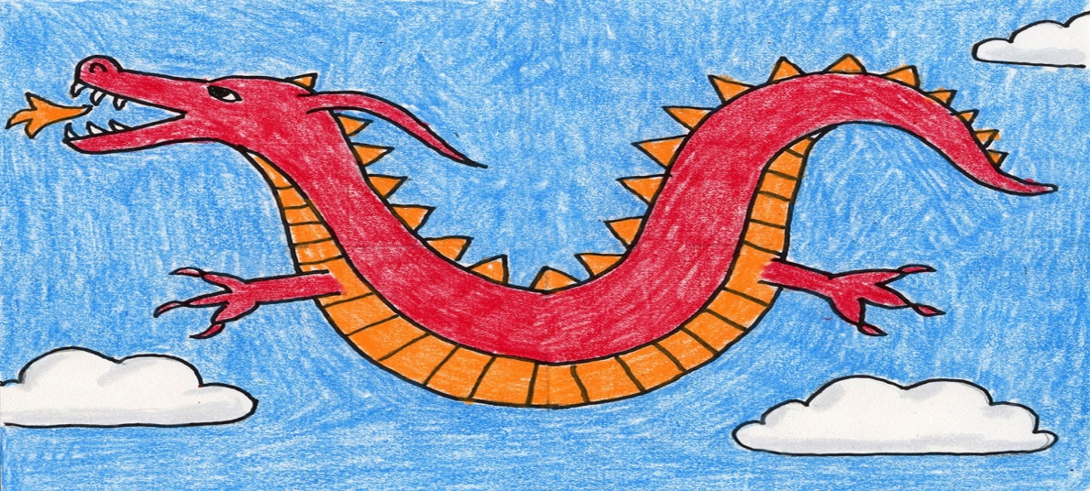

VI. Write True or False :-
- Aanya feels the dragon has scary eyes. (False)
- Dragon is feeling sad and lonely. (True)
- The Dragon is happy in the beginning. (False)
- Aanya goes to meet the dragon. (True)
VIII. Answer the questions in the Two or Three sentence:-
- Do you think this part from the story is real or imaginary ?
“The dragon stretched his wing and it felt so good! The dragon and the princess flew up in the sky”
Ans:- Imaginary there are dragon in real life

